NC DPI Math Resources (and more) for K-5
Description | Site | Image
Symbaloo  (contains most of the links below) | www.symbaloo.com/mix/commoncoremath | 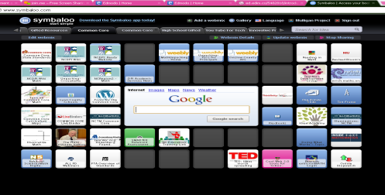
Common Core Standards | All www.corestandards.org  Math http://corestandards.org/assets/CCSSI_Math%20Standards.pdf
NC DPI Math Wiki  (most recent updates by grade level, one-pager of standards, and more…) | http://maccss.ncdpi.wikispaces.net/Elementary+Mathematics | 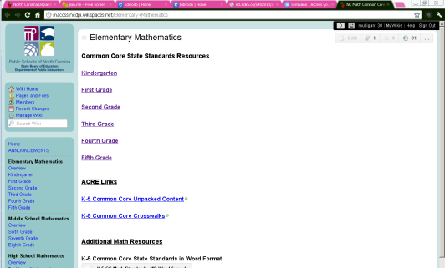
NCDPI Math Support Tools  (unpacking, crosswalks, | http://www.ncpublicschools.org/acre/standards/common-core-tools/
My Math Unpacking Site | www.mathunpacking.weebly.com
Smarter Balanced  Developing the next generation of assessments (to begin 2014-2015) | www.smarterbalanced.org
Developing Effective Fractions  (What Works Clearinghouse K-8 Fractions) | http://ies.ed.gov/ncee/wwc/PracticeGuide.aspx?sid=15 | 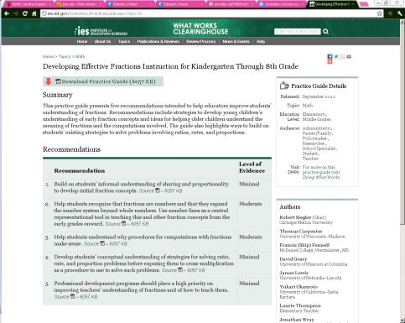
PTA Parent Guides Grade by Grade | http://www.pta.org/4446.htm  Scroll about ½ way down the page in the middle for the Parent Guides
Pearl Trees  (Created by Stephen Taylor of Onslow County MIT) | http://www.pearltrees.com/#/N-f=1_4104432&N-fa=4102559&N-p=32695607&N-play=0&N-s=1_4104432&N-u=1_494830  Expanding “Trees” that includes links to Common Core, Unpacking, Crosswalks, and more

