Foundations of Algebra Diagnostic Test

Solve:

1.) 27,612 - 13,579 _____________________

2.) 2.8 + 4.53 _____________________

3.) 3.5 – 1.74 _____________________

4.) If you owe $423.97 on credit card and you pay $182.34, how much do you still owe?

______________________

5.) 470, 872 + 35,289 ______________________

6.) 2,232 $∙$ 13 ______________________

7.) 786 6 ______________________

8.) Ming has 6 stacks of quarters. Each stack has 23 quarters. How many quarters does Ming have?

______________________

9.) The slowst mammal, the South American sloth, takes about 9 hours to go 1 mile. How many miles has the sloth traveled after 108 hours?

______________________

10.) Reduce to lowest terms:  ______________________

Change the improper fraction into a mixed number and the mixed number into an improper fraction.

11.)  ______________________

12.) 

Reduce each answer to lowest terms, but it is not necessary to change improper fractions to mixed numbers.

13.)  ______________________

14.)  _____________________

15.)  _____________________

16.) 11 - 10 _____________________

17.) 2(5 + 6) = 10 + 12 _____________________

18.) Give the value of the unknown: 45 + x = 88 +45

_____________________

19.) Solve  _____________________

Write each expression

20.) 4 times the sum of a number and 2 _____________________

Simplify.

21.) 3(x + 9) _____________________

22.) (4-2)(8** _____________________**

23.) 3 – (-6) _____________________

24.) 8  _____________________

25.) -5x + 2y  _____________________

26.) 7x + 3 = 4x – 4 _____________________

27.) -4.3p – 7 = 14.5 _____________________

Solve

28.) A sign on the road going over Rabbit Run Pass says “7% grade.” That number represents the steepness (or slope) of the road. Which of the following represents that slope?

1. $\frac{1}{7}$ C. $\frac{7}{10}$
2. $\frac{.07}{100}$ D. $\frac{7}{100}$

29.) Reggie has 20 pieces of gum in a bag. He has 5 red, 4 blue, 5 green, and 6 purple pieces of gum. He did an experiment where he chose a piece of gum out of the bag without looking. What is the probability of picking a blue piece of gum out of the bag without looking?

A. 20% C. 5%

B. 25% D. 10%

Convert the fraction to a decimal.

30.) $\frac{1}{8}$ = _____________________

31.) Name the quadrant in which the point (-3, 1) is located.

_____________________

32.) What is the range of the solution set of the equation 2x + 4y = 8 if the domain is {-2, 0, 2}?

A. {4, 6, 8} C. {-1, -2, -3}

B. {1, 2, 3} D. {0, 4, 8}

33.) The triangle QRS is shown below.

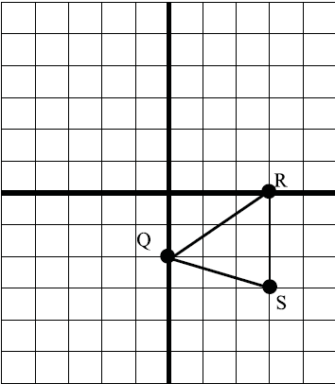

Calculate the length of line segment RS. _____________________

34.) What is the domain of the relation shown in the mapping?

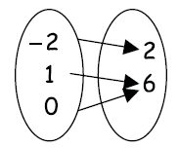

A. {-2, 0, 1, 6} C. {0, 1, 6}

B. {2, 6} D. {-2, 0, 1}

35.) The graph shows the total number of miles Tyrone ran in a week. Estimate the total number of miles Tyrone ran in 8 days.

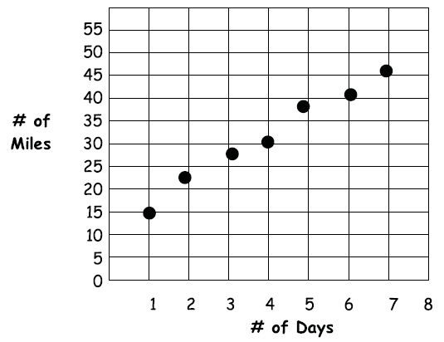

A. {4, 6, 8} C. {-1, -2, -3}

B. {1, 2, 3} D. {0, 4, 8}

36.) Which is the scatter plot for the data set (5, 1000), (7, 1200), (8, 1300)?

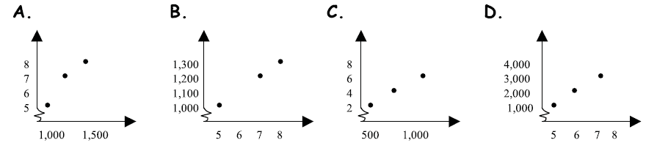

Identify m and b, and graph the line.

37.) $y=\frac{1}{4}x+2$ 

m = ______ b = ______

Circle the correct solution(s) for the inequality.

38.) a > 3

A. -4 B. 0 C. 3 D. 6

Graph each inequality.

39.) c < -2 

40.) x > -5 

Solve.

41.) A student wrote 2x + y > 30 to represent a sentence. Which sentence below could be the sentence?

A. The sum of 2x and y is less than 30.

B. The sum of 2x and y is at most 30.

C. The sum of 2x and y is at least 30.

D. the sum of 2x and y is no more than 30.

Write the expression in exponential form.

42.) $m∙m∙m∙m∙m=$

_____________________

Simplify.

43.) $\left(4mn^{3}p^{4}\right)\left(2mnp\right)=$

_____________________

44.) $m^{-6}=$

_____________________

45.) $-3m^{2}\left(5m^{3}n+7n\right)=$

_____________________